**Capstone Project**

**The Battle of Neighborhoods**

**Opening of Turkish Restaurant in Bucharest**

1. **Introduction (Business Problem)**

**1.1 Background**

Bucharest is the capital and biggest city of Romania, just as its social, modern, and budgetary focus. It is situated in the southeast of the nation, at coordinates: 44°25′57″N 26°06′14″E, under 60 km (37.3 mi) north of the Danube River and the Bulgarian outskirt. [1]

Bucharest is the center point of the Romanian economy and industry, representing around 24% (2017) of the nation's GDP and around one-fourth of its mechanical creation, while being occupied by 9% of the nation's populace. Bucharest has 2 million populaces and comprises of 6 parts. Neighborhoods and populaces in divisions are as underneath: [1]

* **Sector 1** *(population 227,717):* Dorobanți, Băneasa, Aviației, Pipera, Primăverii, Dămăroaia, Grivița
* **Sector 2** *(population 357,338):* Pantelimon, Colentina, Iancului, Tei, Floreasca, Moșilor, Obor, Fundeni,
* **Sector 3** *(population 399,231):* Vitan, Dudești, Titan, Centrul Civic, Dristor, Lipscani
* **Sector 4** *(population 300,331):* Berceni, Olteniței, Progresul, Văcărești, Tineretului
* **Sector 5** *(population 288,690):* Rahova, Ferentari, Giurgiului, Cotroceni, 13 Septembrie, Dealul Spirii
* **Sector 6** *(population 371,060):* Giulești, Crângași, Drumul Taberei, Militari, Grozăvești(Regie), Ghencee

As expressed by the Mercer universal overviews for personal satisfaction in 231 urban communities around the globe, Bucharest involved the 109th spot in 2019. Bucharest, at number 109, positions low in the European rundown however better than other European urban communities, for example, Sofia (116th) and Belgrade (139th). [2]

Numerous areas, especially in the southern piece of the city, need adequate green space, are framed of squeezed high thickness square of pads. This may influence individuals' life also.

**1.2. Problem**

In this project, I will explore that if there is any acceptable area in Bucharest for opening Turkish eatery and it truly qualities to open one.

**1.3. Interest**

Anybody needs to open another setting in any geographic area might be keen on this task by altering search models.

**2. Data section**

**2.1 Data sources**

To consider the problem we can list the data as below:

* I get the neighborhood data of Bucharest from Wikipedia [3]
* I use python geocoder library to get geographical coordinates of neighborhoods[4]
* I use **Foursquare API** **venues explore** method to get the venues of given neighborhoods of Bucharest [5].
* I use **Foursquare API venues method** to get ranks and likes of restaurants by given venue id [5].

**A. References:**

* [1] [Bucharest — Wikipedia](https://en.wikipedia.org/wiki/Bucharest)
* [2] [Mercer’s Quality of Life Survey](https://www.romania-insider.com/mercer-bucharest-quality-living-2019)
* [3] [Category:Districts of Bucharest](https://en.wikipedia.org/wiki/Category:Districts%20of%20Bucharest)
* [4] [Python Geocoder Library](https://geocoder.readthedocs.io/)
* [5] [Foursquare API](https://developer.foursquare.com/)

**2.2 Feature Selection and Data Usage**

I will use neighborhood location values to analyze Bucharest geographical structure. I will use folium library of python to draw maps by using given latitude and longitudes of neighborhoods. Selected features will be as below

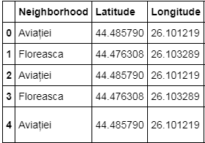

I will use populations of neighborhoods who has big population may need a new restaurant.

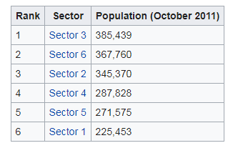 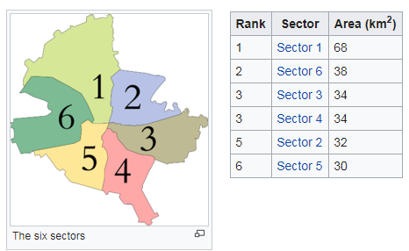

I will classify arrange neighborhoods by utilizing scenes dispersion and checks. Along these lines, I will discover likenesses of neighborhoods which will assist me with choosing area for opening another eatery. Comparable organized neighborhoods may deal with same kind of scene.

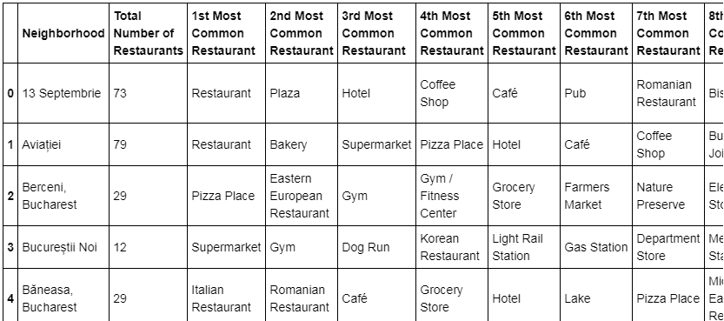

I will utilize scene list category to discover distribution of cafés and Turkish eateries in neighborhoods.

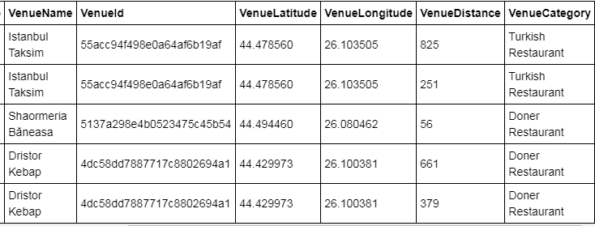

I will utilize likewise evaluations and preferences of cafés in the zones. It might assist me with finding area with awful appraising eateries which may require another eatery.

